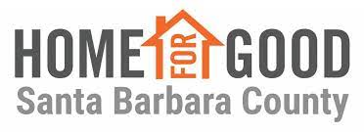

Isla Vista Beautiful
About the United Way of Northern Santa Barbara County: United Way improves lives by mobilizing the caring power od communities around the world to advance the common good. In Northern Santa Barbara County, we too live United.
About Home For Good Santa Barbara County: supports a Coordinated Entry System, a no-wrong door, countywide system that engages and connects individuals and families experiencing homelessness to the optimal resources for their needs. United Way/Home For Good Santa Barbara County provides Coordinated Outreach across Santa Barbara County. We believe that everyone deserves a safe place to call home for good.
About the Isla Vista Beautification Project: This is a work experience program focused on the beautification of the Isla Vista Community.
The specific tasks include:
- Power-washing of sidewalks
- Trash pickup in areas not covered by the Isla Vista Parks and Recreation Department
- Graffiti and trash identification, documentation and removal
- Identification of the obstruction of the public right of way
- Other beautification projects as identified
Who Do We Seek To Employee: Our Beautification Staff and Volunteers are experiencing homelessness, at-risk of becoming homeless or newly housed. The majority of our Beautification Staff and Volunteers learn about our services through outreach from our existing AmeriCorps Members and United Way Staff. Volunteers and Staff are trusted to complete tasks, show up on time, and work well with others.
Employment Requirements: In order to be considered for employment at the Isla Vista Beautiful with the United Way of Northern Santa Barbara County the following steps are necessary:
1. Fill out an employment application, completely and accurately.
2. Pass the initial screening of applicants including a Criminal Background Check as well as be cleared through the National Sex Offender Public Website.
3. After the screening process, the applicant will be interviewed by United Way Staff. A follow-up interview may take place depending on the applicant’s position and score in the first interview.
4. It is the option of the hiring personnel to check the references of those candidates applying for part-time positions.
1
Prospective employees will receive consideration without discrimination because of race, creed, color, sex, sexual orientation, age, national origin, physical or mental disability or veteran status.
EMPLOYMENT APPLICATION PERSONAL
First: ________________________________________________________________
Last: ________________________________________________________________
Address: ________________________________________________________________
Phone: ________________________________________________________________
Are you at least 18 years of age? ________________________________________________________________
Other special training or skills (languages, machine operation, etc.): ___________________________________________________________________________________________________ ___________________________________________________________________________________________________
Are you legally eligible for employment in the United States?____________________________________
When will you be available to begin work:___________________________________________________________

EDUCATION
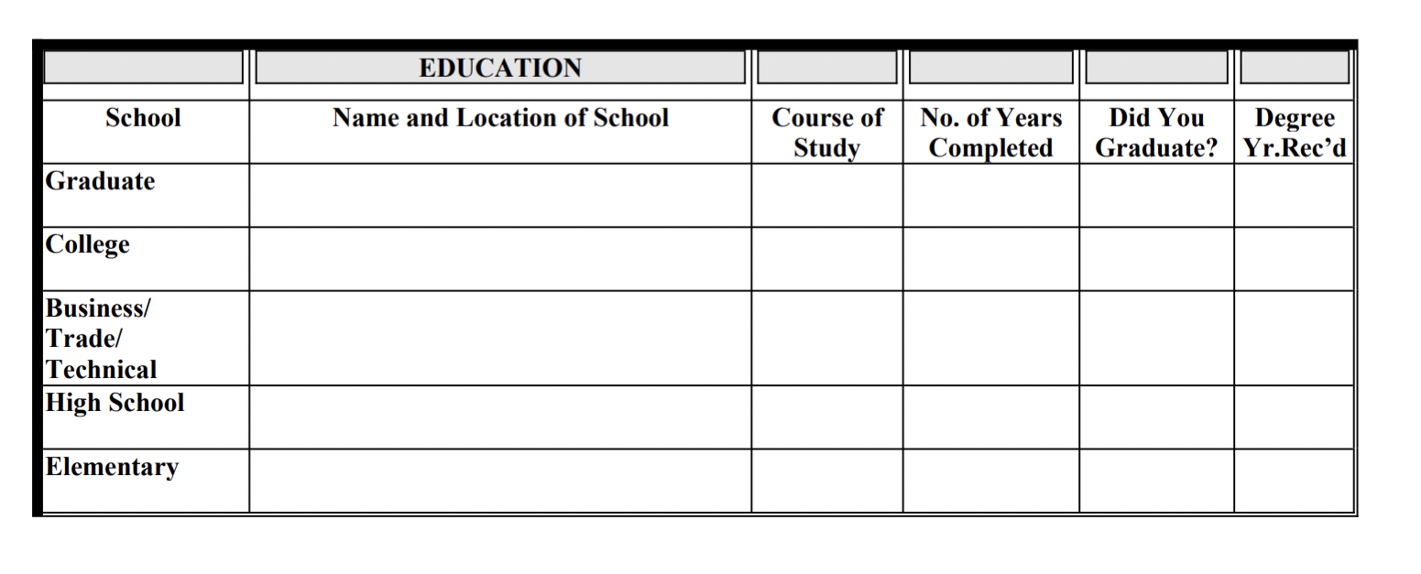

2

Membership in professional or civic organizations and/or volunteer experience
(Exclude those which may disclose your race, creed, color, sex, sexual orientation, age, national origin, physical or mental disability or veteran status, religion or national origin)
___________________________________________________________________________________________________
___________________________________________________________________________________________________
___________________________________________________________________________________________________
EMPLOYMENT HISTORY
Please give accurate, complete full-time, part-time or volunteer employment information. Start with your present or most recent employer. Do not omit any jobs you have held. Please explain any periods of time in which you were not employed. A resume may be attached but not substituted for completing the information required below
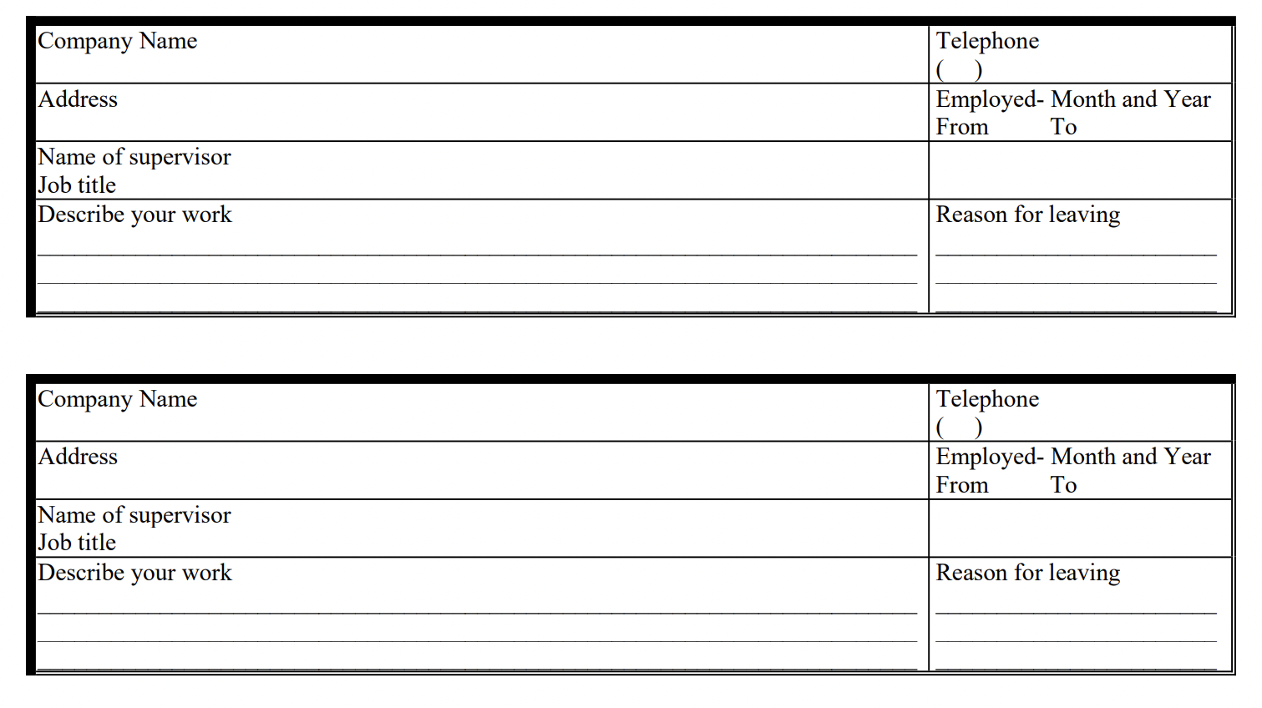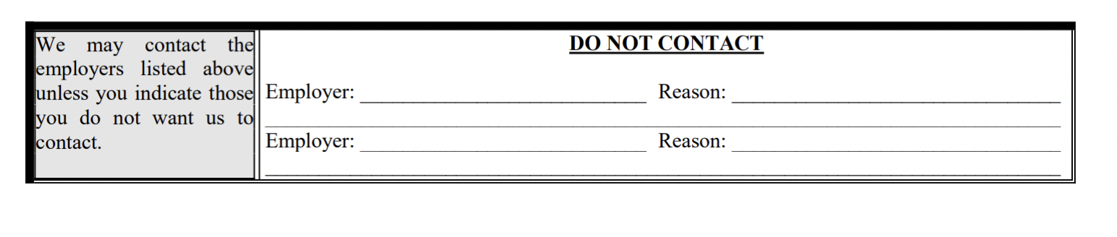
3

PHYSICAL RECORD
Are you able to perform the essential functions of the position applied with or without reasonable accommodations? ________________________________________________________________________________

IN CASE OF EMERGENCY NOTIFY
NAME ____________________________________________________________________________________________
ADDRESS _________________________________________________________________________________________
___________________________________________________________________________________________________
PHONE: _________________________________________________________________________________________
After it has been determined that I meet the minimum employment qualifications, I understand that I will be asked to disclose if I have any criminal conviction(s).

ATTENTION - THIS STATEMENT MUST BE SIGNED
Read the following paragraphs carefully before signing this Statement. A false answer to any question in this statement may be grounds for not employing you, or for dismissing you after you begin work. All the information you give will be considered in reviewing your statement.

AUTHORITY FOR RELEASE OF INFORMATION
I have completed this statement with the knowledge and understanding that any or all items contained herein may be subject to investigation prescribed by Unite dWay resolution and I consent to the release of information concerning my capacity and fitness by employers, educational institutions, law enforcement agencies, and other individuals and agencies, to duly accredited investigators or United Way personnel for that purpose.

CERTIFICATION
I hereby certify that the information contained in this Application form is true and correct and agree to have the statements checked by the United Way Northern Santa Barbara County unless I have indicated to the contrary. I authorize the references listed to provide the United Way with any and other pertinent information that they may have. Further, I release all parties and persons from all liability for any damages that may result from furnishing such information to the United Way as well as from the use or disclosure of such information by the United Way or any of its agents, employees or representatives. I understand that any misrepresentation, falsification, or omission of information from this Application may result in my failure to receive an offer or, if I am hired, in my dismissal from employment. I understand that if I am offered employment by the United Way, my employment will be at-will, meaning that either the United Way or myself may terminate the employment relationship at any time, with or without cause and with or without advance notice. I understand that no employee or representative of the United Way other than the Chief Executive Officer has any authority to enter into any agreement inconsistent with the at-will nature of the employment relationship. I understand that any such agreement must be in a document signed by both parties. I also understand that all offers of employment are conditioned on the receipt of satisfactory responses to reference requests and the provision of satisfactory proof of the applicant's legal ability to work in the United States.
___________________________________________________ ________________________________________
Signature (sign in ink) Date
4
CONSENT TO OBTAIN BACKGROUND CHECK
Consent to having your criminal state and federal background history checks conducted by the Northern Santa Barbara County/Santa Barbara County AmeriCorps Partnership for Veterans and People Experiencing Homelessness
______________________________________ ______________
Name Date
_____________________________________
Signature
By signing, you consent to having your criminal state and federal background history checks conducted by the SBC AmeriCorps Partnership for Veterans and People Experiencing Homelessness, as well as be cleared through the National Sex Offender Public Website

